**A SUMMER INTERNSHIP PROGRAMME**

**ON**

**“CONSUMER BEHAVIOUR”   
AT**

**MIDNIGHT CAKES**

**A project report submitted to**

**GUJARAT TECHNOLOGICAL UNIVERSITY**

**As a partial fulfillment of requirement for the award of**

**MASTER OF BUSINESS ADMINISTRATION**

**Submitted By:**

**JHANAVI S. GADHAVI**

**Enroll No: 147360592019**

**Under the guidance of**

**PROF. JAGRUT VASAVADA**

**N.R.V.I.B.M.S.**

**INSTITUTE   
N.R.Vekariya Institute of Business Management Studies**

**Junagadh 362001**

**

**DECLARATION**

I **Jhanavi Gadhavi** hereby declare that the information presented is correct to the best of my knowledge and the analysis is as per the norms and guidelines provided for the report. I have utilized the requisite concepts and applied the required methodologies to analyze the primary data collected to reach the conclusion present in the report.

**Date: Jhanavi Gadhavi**

**PREFACE**

Education is the process of sharpening one’s mind and which is given in the school & colleges in form of various subjects. When any subject is thought theoretically in class it is known as academics, but when it is studied with the subject application in real life. It is known as Professional education.

The field of commercial study consists of business administration, which is the good mixture of both theory subject and practical subject. Thus, it makes the students familiar with the running of various industries. As a student of MBA, a professional degree courses, it required having the knowledge about theoretical as well as practical knowledge. Theoretical knowledge provided me by the experienced staff of my college and the practical knowledge and training is provided by the “**Midnights cakes**”, Ahmadabad.

The report contains all the detail about all the products of Midnight cakes in Ahmadabad city. It involves specification and the analysis of the market with the help of questionnaire. The report has been made conclusive and suggestive. I hope that this report will prove to be useful to the organization as and will be able to provide useful information to its readers.

**Jhanavi Gadhavi**

**ACKNOWLEDGEMENT**

A successful project can never be prepared by the single effort or the person to whom project is assigned , but it also demand the help and guardianship of some conversant person who helps in the undersigned actively or passively in the completion of successful project.

It is my honor to get an opportunity to pursue my summer internship with “Midnight Cakes”, Ahmadabad. I would like to thank Midnight Cakes for giving me an opportunity to undertake a summer internship in the company.

My special thanks to Mr. Krunal Odedara and Mr. Naman Sherasia owner of the midnight cakes for providing me all needed information to complete my project.

I extend my sincere gratitude to Mr. Meghal Joshi G.M for providing all help to complete my project.

I express my heartiest thanks to my Director Mr. Rajesh Patel, HOD S.A. Munshi and my academic mentor Prof. Jagrut Vasavda for his valuable suggestions and guidance at various stages of the project.

I would like to thank my faculty for providing their guidance.

I also take the opportunity to thank all those who helped me in completing my projects in various ways.

Finally I would like to thank my family and friends for giving me constant support and encouragement.

**THANK YOU ALL**

**Jhanavi Gadhavi**

**COLLEGE CERTIFICATE**

J.J.C.E. Trust Sanchalit



Bilkha Road,

JUNAGADH - 362001

Date:

This is to certify that **Miss Jhanavi S. Gadhavi** Student of **M.B.A. SEM - III** of this college has taken industrial training undergone at “Midnight cakes”, Ahmadabad for 45 days as a part of her study.

She has prepared project report and submitted a copy of the project report of mentioned training to the institute.

**Project Guide Director**

Prof. Jagrut Vasavada Dr. Rajesh Patel

**COMPANY’S DIRECTOR’S MESSAGE:**

Money is by product of our business. Our business is customer centric. Customer satisfaction is our first priority. I started this service when I experienced this service on the first hand. So I want everybody’s celebration to be as special as mine was. We are really trying very hard to make each celebration unforgettable.

**Mr. Naman Sherasia**

**CO-FOUNDERS MESSAGE:**

As we are into service industry, we believe in complete customer satisfaction. If our customers are happy, we are happy. In near future, we will be leading service provider in this industry just to make even more customer happy.

**Mr. Naman Sherasia**

*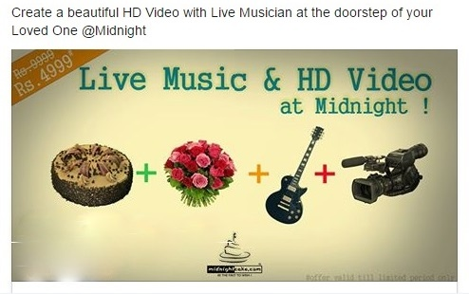*

|  |  |  |
| --- | --- | --- |
| Sr. No | Particular | Page No. |
| Part 1 | **Introduction** | **1** |
|  | Introduction of company | 2 |
|  | Introduction of Topic | 8 |
|  | Introduction of Topic with company | 11 |
|  |  |  |
| Part 2 | **Review of Literature** | **16** |
|  |  |  |
| Part 3 | **Details about the study** | **22** |
|  | Problem of study | 23 |
|  | Objectives of study | 24 |
|  | Setting of Hypothesis | 25 |
|  | Scope of study | 28 |
|  | Rationale of study | 29 |
|  |  |  |
| Part 4 | **Research Methodology** | **30** |
|  | Research Design | 32 |
|  | Sources of Data Collection | 33 |
|  | Population of study | 35 |
|  | Sample size | 35 |
|  | Tools & Techniques | 36 |
|  |  |  |
| Part 5 | **Analysis & Interpretation** | **38** |
|  | Testing of Hypothesis | 52 |
|  | Contribution from the study | 55 |
|  |  |  |
| Part 6 | **Findings, suggestions and conclusion** | **56-59** |
|  |  |  |
| Part 7 | **Bibliography** | **60** |
|  |  |  |
| Part 8 | **Annexure** | **62** |

**PART 1**

**INTRODUCTION**

**

**INTRODUCTION OF COMPANY**

Mid night cake is a unique concept to give a surprise to your friends, family and loved ones by sending delicious cake, fresh flowers, branded chocolates , gifts, ideas and much more to their doorstep at midnight without moving out of your home or office , you can make every celebration simply unforgettable with midnight cake. Online booking system makes it possible to book your order while travelling or staying far away from your loved once and yet not compromising on celebrating with personal touch. Free, fast, and same day delivery across various cities gives you the flexibilities of fast booking from anywhere in the world, across 365 days a year, irrespective of holiday.

Midnight.com is a website owned and copyright by proton multi service, a venture involved in providing truly value added premium service. The services provided by midnight cake are limited edition services which targets to cater clients. Innovation and quality are the two arms of midnight cake which helps to cater the esteem customer base and simultaneously give a strong fight to the competitors. Proton service is a venture, which comes into existing in 2010 with a young & dynamic teamwork by few passionate and enthusiastic guys who loved to serve people on their special occasion to make it memorable lifetime by giving innovative surprise at their doorstep @ sharp 12:00 midnight! Initially designed as project, midnight cake was founded by a student of MBA from Ahmadabad. Now turned to be a professionally executed business model has its presence in multiple location of India. It also serves the corporate world having highly paid professional and huge employee base. It has a product range which does not provide large number of option but, limited and premium quality standard product only. Like many others, company believes in material, “less is more”, that’s the reason unlike other websites, and they have focused more on their service rather than providing multiple options with minor differences. They are also committed to provide a class apart service with extra ordinary quality products which they display on their website.  Company’s Mission “To become one stop online solution to every single celebration needs, required to make it memorable lifetime in some or the other way” Its Motto “A Satisfied Customer does more Powerful & Fruitful Marketing than an unsatisfied Marketing Person. That’s why they give equal importance to both: Customer as well as Employee “Birthday, New Year, Marriage Anniversary or any other special DAY comes only once a year. Company continuously working hard to make each of such DAYS a memorable one, so that your rest of the 365 days goes well memorizing that special DAY of celebration!

**HISTORY AND DEVELOPMENT**

The start time of company, it’s been about five years since they had started moving from cake shop with multiple verities of products to pure online celebration store with only one single product. Then they had energized with lots of smiling faces in multiple possible celebrations and got inspired to being part of more celebrations with more verity of products. Since then, they went for a major brand makeover and making themselves more ‘up market’ with more verities of products with more serviceable areas. But probably they were not ready for bigger picture financially. There has been small newspaper Ads and web Ads. But they knew, unlike other e-commerce companies the marketing to be worked only when the product and service was strong. Midnight cake’s real achievement has been in solving the problem to be make celebration unforgettable in absence of them.

The store started with selling one single product in one single city and from 2011 starting out to selling cake, Flowers, Gifts, Green plants in multiple quantities with different verities in multiple cities. As of now, Midnight cake service is available over 22\*cities.

***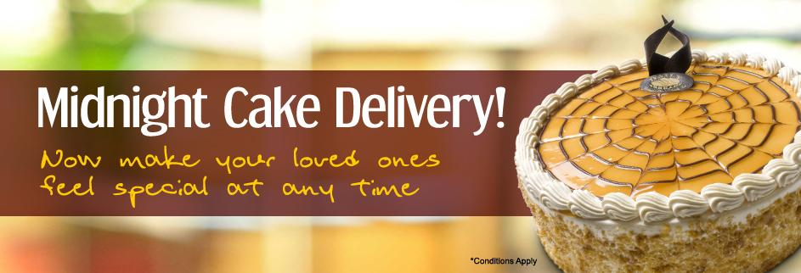***

**COMPANY PROFILE**

Company name : Midnight Cakes (Proton Multi Services)

Corporate office : PMS, 306, 3rd Floor, Zodiac Square, Nr. Thaltej cross road, Thaltej, Ahmadabad

Tel. No. : 079-40213113

Email : info@midnightcake.com

Web site : [www.midnightcakes.com](http://www.midnightcakes.com)

Name of product : Online Celebration Store

Total city : Ahmadabad, Surat, Rajkot, Baroda, Mumbai, Pune,

Nasik, Nagpur, Chennai, Bangalore, Delhi, Noida,

Hyderabad, Kanpur, Kolkata, Jaipur, Lakhnow, Bopal,

Indore, Faridabad.

Bankers : All bank Debit cards, ATM card and Net Banking

Establish Year : 2010

Turnover : Confidential

Logo :

**

*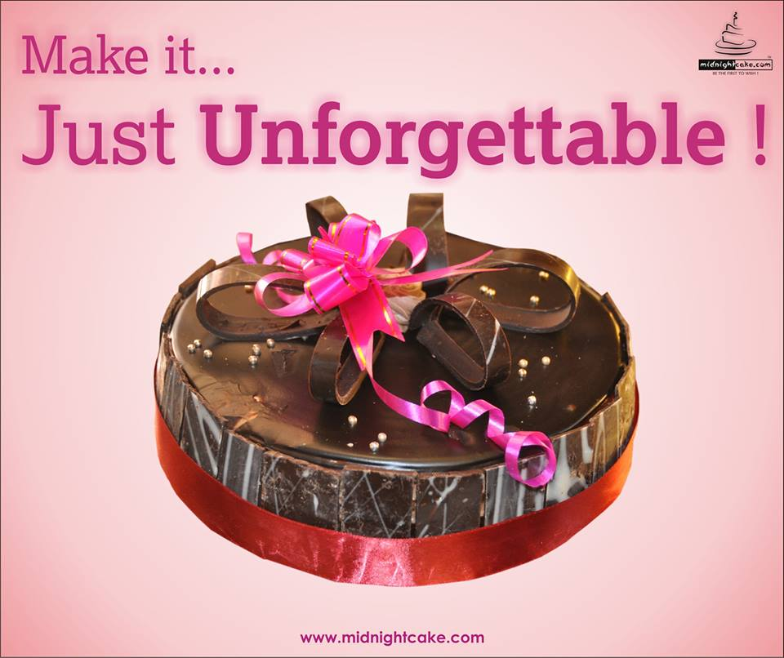*

**Cakes delivery, flowers Delivery and services of Midnight Cakes**

*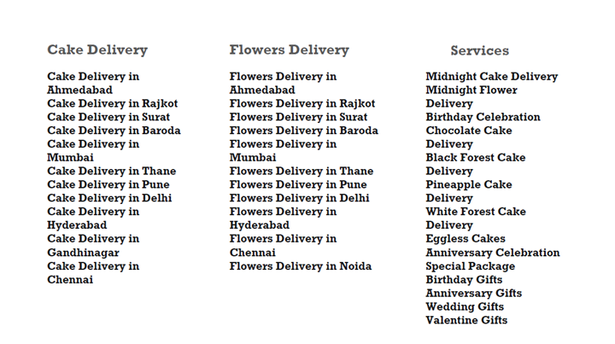*

**Products of Company**

* Cakes
* Chocolates
* Flowers

*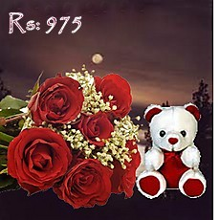* *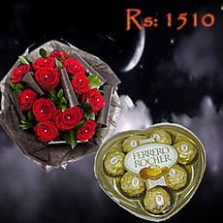*

*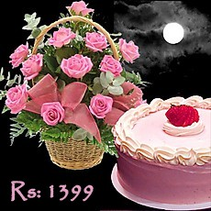* *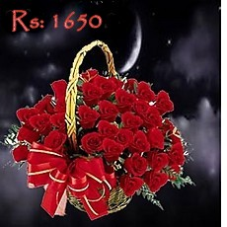*

*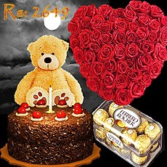* *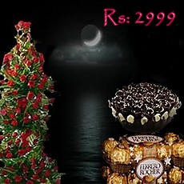*

**INTRODUCTION OF TOPIC**

### Who is a Consumer?

Any individual who purchases goods and services from the market for his/her end use is called a consumer.

In simpler words a consumer is one who consumes goods and services available in the market.

Example – Neel might purchase a tricycle for his son or Dev might buy a shirt for himself.

In the above examples, both Neel and Dev are consumers.

### What is consumer Interest?

Every customer shows inclination towards particular products and services. Consumer interest is nothing but willingness of consumers to purchase products and services as per their taste, need and of course pocket.

Let us go through the following example:

Both Diya and Mita went to the nearby shopping mall to buy dresses for themselves. The store manager showed them the best dresses available with him. Diya immediately purchased two dresses but Mita returned home empty handed. The dresses were little too expensive for Mita and she preferred simple and subtle designs as compared to designer wears available at the store.

In the above example Diya and Mita had similar requirements but there was a huge difference in their taste, mind set and ability to spend.

**WHAT IS CONSUMER BEHAVIOR?**

Consumer behavior is the study of how individual customers, groups or organizations select, buy, use, and dispose ideas, goods, and services to satisfy their needs and wants. It refers to the actions of the consumers in the marketplace and the underlying motives for those actions.

Marketers expect that by understanding what causes the consumers to buy particular goods and services, they will be able to determine which products are needed in the marketplace, which are obsolete, and how best to present the goods to the consumers.

The study of consumer behavior assumes that the consumers are actors in the marketplace. The per­spective of role theory assumes that consumers play various roles in the marketplace. Starting from the information provider, from the user to the payer and to the disposer, consumers play these roles in the decision process.

The roles also vary in different consumption situations; for example, a mother plays the role of an influence in a child’s purchase process, whereas she plays the role of a disposer for the products consumed by the family.

One thing that we have in common is that we all are consumers. In fact everybody in this world is a consumer. Every day of our life we are buying and consuming an incredible variety of goods and services. However, we all have different tastes, like, dislikes, and adopt different behavior patterns while making purchase decisions

The term consumer behavior refers to the behavior that consumers displaying searching for purchasing using evaluation and disposing in searching for  purchasing using evaluating and disposing of products and services that they exact will satisfy o how individuals make decisions to send their available resources (time, money and effort) on consumption related items. It includes the study of what they buy, why they buy, when they buy it, where they buy it, how often they buy it and how often they use.

**Some selected definitions of consumer behavior are as follows:**

* Consumer behavior is the actions and decision processes of people who purchase goods and services for personal consumption.
* Consumer behavior is the decision process and physical activity, which individuals engage in when evaluating, acquiring, using or disposing of goods and services.
* Consumer behavior displayed by the consumers during the acquisition, consumption and disposition of products, services, time and ideas by decision making units.
* It is the body of knowledge which studies various aspects of purchase and consumption of products and services by individuals with various social and psychological variables at play.

Consumer behavior is helpful in understanding the purchase Behavior and preferences of different consumers. As consumers, we differ in terms of gender, age, education, occupation, income, Family setup, religion, nationality and social status. Because of this different background factors, have different needs and we have only buy those products and services, which we think, will satisfy our needs.

**INTRODUCTION OF TOPIC WITH COMPANY**

**A Model of Consumer Behavior:**

A consumer decisions to purchase a particular product of service is the result of complex interplay of a number of variables. The starting point of the decision process is provided by the company’s marketing stimuli in the shape of product, promotion, and price and distribution strategy. Consumer often purchases new products that are associated with a favorable viewed brand name.

The term consumer behavior refers to the behavior that consumer displaying searching for purchasing, using, evaluating and disposing of products and services that they expect will satisfy these needs. The study of consumer behavior in the study of how individuals make decisions to spend their available resources (time, money, effort) on consumption related items. It includes the study of what they buy, why they buy, when they buy, where they buy, how often they buy and how they use.

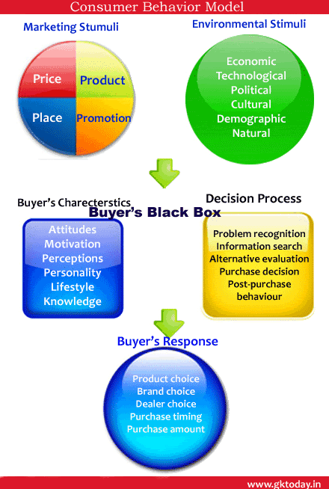

**DETAILED MODEL OF INFLUENCING OF CONSUMER BEHAVIOR**

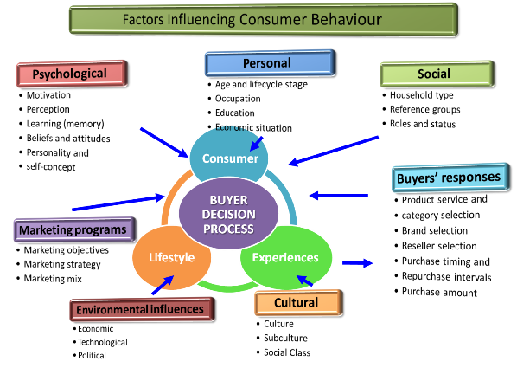

Consumer’s behavior towards Midnight Cakes is very good. Midnight Cakes have good palace in the mind of customers. Majority of the people highly satisfy with the facility of Midnight Cakes.

**Review of customers towards Midnight Cakes:**

*2 april.jpg*

*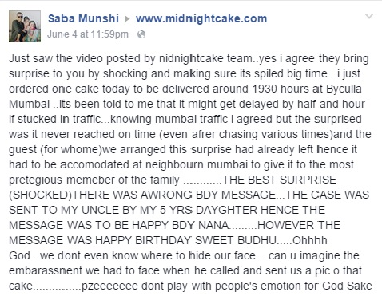*

*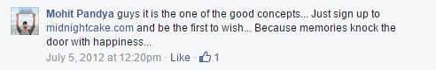*6

*july 20.jpg*

*2 octo.jpg*

*3 octo.jpg*

*Untitled4.jpg*

*Untitled3-3.1.jpg*

*june 6.jpg*

*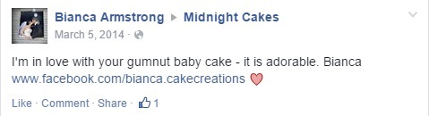*

*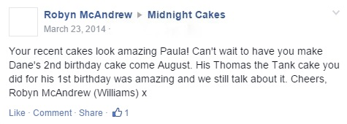*

*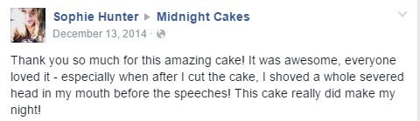*

**PART 2**

**REVIEW OF LITERATURE**

**

**Review of Literature on Measuring the Customer Experience in Online Environments**

February 1, 2000 byThomas P. Novak

Intuition and previous research suggest that creating a compelling online environment for Web consumers will have numerous positive consequences for commercial Web providers. Online executives note that creating a compelling online experience for cyber customers is critical to creating competitive advantage on the Internet. Yet, very little is known about the factors that make using the Web a compelling experience for its users, and of the key consumer behavior outcomes of this compelling experience.

Recently, the flow construct has been proposed as important for understanding consumer behavior on the World Wide Web, and as a way of defining the nature of compelling online experience. Although widely studied over the past 20 years, quantitative modeling efforts of the flow construct have been neither systematic nor comprehensive. In large parts, these efforts have been hampered by considerable confusion regarding the exact conceptual definition of flow.

Source: <http://pubsonline.informs.org/doi/abs/10.1287/mksc.19.1.22.15184>

**Review of literature on consumer behavior**

**Feb, 2002 by Moneesha Pachauri**

In order to develop a framework for the study **consumer behavior** it is helpful to begin by considering the evolution of the field of consumer research and the different paradigms of thought that have influenced the discipline. As described in this article, a set of dimensions can be identified in the literature, which can be used to characterize and differentiate the various perspectives on consumer research. It is argued that consumer behavior itself emerged as a distinct field of study during the 1960s; and is characterized by two broad paradigms, the positivist and the non-positivist. The positivist paradigm encompasses the economic, behavioral, cognitive, motivational/trait/attitudinal, and situational perspectives; these perspectives are referred to as the traditional perspectives as they pre-date the development of the non-positivist paradigm. The positivist paradigm, which is still the dominant paradigm, emphasizes the supremacy of human reason and that there is a single, objective truth that can be discovered by science. This paradigm regards the world as a rational and ordered place with a clearly defined past, present, and future. The assumption of rationalism is therefore fundamental to the traditional perspective.

Sources: [*www.themarketingreview.com*](http://www.themarketingreview.com)

**Review of literature on consumer behavior**

**October 20, 2011 by** [*Richard*](http://writepass.com/journal/author/richard/)

**Consumer Behavior Christopher (1989)** studied the shopping habits of consumers to form an idea of whether or not the store concepts, product ranges and strategies of the companies are appropriate towards consumer requirements. He believed that consumer behaviors are unpredictable and changing continuously changing; while trying to under try to understand how individual or group make their decision to spend their available resources on consumption-related items. These are factors that influence the consumer before, during, and after a purchase for example, feedback, from other customers, packing, advertising, product appearance, and price. The essence of this approach is critical for organizational success, so that they can have a better understanding of their customer behaviors. The physical action or behavior of consumer and their buying decision every day can be measured directly by marketers. For that reason many organizations these days are spending lot of their resources to research how consumer makes their buying decision, what they buy, how much they buy, when they buy, and where they buy.  To get a well coherent result, organizations normally looked at these behavior bases their analysis on difference conceptions; whether customers buying behavior were measured from different perspectives, such as product quality and better service, lower price structured etc.

Sources:*<http://writepass.com/journal/2011/10/free-consumer-behaviour-literaturereview/>*

**Review of literature on consumer behavior**

[**March 5, 2015**](http://research-methodology.net/a-brief-literature-review-on-consumer-buying-behaviour/)**by**[**John Dudovskiy**](http://research-methodology.net/author/admin/)

The topic of consumer behavior is one of the massively studied topics by the researchers and marketers in the past and still being studied. Researchers show different reasons as to why consumer behavior has been the topic of many academics and researchers. One of the common views is that understanding consumer behavior has become a factor that has a direct impact on the overall performance of the businesses **(Kotler and Keller, 2012)**. Another view suggests that understanding consumer behavior has become crucial especially due to fierce competition in retail industry in the UK and worldwide **(Lancaster et al, 2002).** This chapter will introduce some other areas of research background of consumer behavior addressing the works of researchers and marketers. Moreover, consumer decision making process, in particular, five stages of consumer decision making process will be discussed in detail.

Source: [*http://research-methodology.net/a-brief-literature-review-on-consumer-buying- behavior/*](http://research-methodology.net/a-brief-literature-review-on-consumer-buying-%20%20%20%20%20%20%20behaviour/)

**Review of literature on consumer behavior**

**A. Abdul Brosekhan M.B.A.1, (Ph.D.)**

In Present Marketing Scenario, the Study of Consumer Behavior has become essential. Consumers are the kings of markets. Without consumers no business organization can run. All the activities of the business concerns end with consumers and consumer satisfaction. Customer behavior study is based on consumer buying behavior, with the customer playing the three distinct roles of user, payer and buyer. Consumer buying behavior has become an integral part of strategic market planning. In order to develop a framework for the study consumer behavior it is helpful to begin by considering the evolution of the field of consumer research and the different paradigms of thought that have influenced the discipline.

Sources: [*http://iosrjournals.org/iosr-jbm/papers/ncibppte-volume-1/1014.pdf/*](http://iosrjournals.org/iosr-jbm/papers/ncibppte-volume-1/1014.pdf/)

**PART 3**

**DETAILS ABOUT THE STUDY**

**

**PROBLEM OF STUDY**

* Time has been a major constraint throughout the study as it has been only for duration of 45 days.
* As this survey was in only Ahmadabad this cannot be stated as an in depth research on this subject.
* Enough care is taken in formulating the questionnaire; still some errors may creep in.
* The consumer behavior varies according to different products.
* Quality verses price was not taken into the consideration.

**OBJECTIVE OF STUDY**

* To analyze the relationship between a Midnight cakes and its customers.
* To study and analyze consumer shopping behavior towards Midnight Cakes.
* To assess the behavior level of different type of customers shopping at Midnight Cakes.
* To identify what type of strategies are suitable for the company to reach the targeted customers.
* To find out the factors which influence the consumption of the products in Midnight Cakes.
* To identify effective an advertising sources which are influencing customer purchasing behavior at Midnight Cakes.
* To find out how the consumers spent their incomes, time on the purchasing of the products.

**SETTING OF HYPOTHESIS**

**What is Hypothesis?**

Hypothesis is usually considered as the principle instrument in research. Its main function is to suggest new experiment and observation. In fact, many experiments are carried out with the deliberate object of testing hypothesis. Decision-makers often face situation wherein they are interested in testing hypothesis on the basis of available information and then take decision on the basis of such testing.

Ordinarily, when one talks about hypothesis, one simply means a mere assumption or some supposition to b proved. But for a researcher hypothesis is a formal question that he intends to resolve. Thus hypothesis may be defined as a proposition or a set of proposition set forth as a provisional conjecture to guide some investigation or accepted as highly probable in the light of established facts.

Hypothesis is just relating to assuming something ordinarily hypothesis mean. But for a researcher may be defined, “A statistical hypothesis is some assumption or Statements which may or may not be true about a population or about probability distribution characterizing gives population which we want to test on the basis of evidence from a random sample up data”.

In simple words hypothesis means apposition of something which needs to be proved or disproved do mainly 2 types of hypothesis like descriptive & relation, depending on what is his requirement he will go for the location of hypothesis.

**Importance:**

* It provides direction to research.
* It spells the difference between precision and haphazardness between fruitful and fruitless research.
* It is a guide to the thinking process of discovery.
* It prevents blind research. It places clear and specific goals before us.
* It enables the investigator to clarify the procedure and methods to be used in solving his problem and to rule out methods are incapable of providing necessary data.
* It serves as a framework for drawing conclusions.

**Characteristics:**

* Hypothesis should be clear and precise.
* It should be capable of being tested.
* It should state relationship between variables, if it happens to be relational hypothesis.
* It should be limited in scope and must be specific.

**There are 2 types of hypothesis:**

1. **Alternative Hypothesis : H1:**

Alternative hypothesis are usually the one which one wishes to prove.

1. **Null Hypothesis :H0:**

Null hypothesis is the one which one wishes to disprove. Thus null hypothesis represent the hypothesis we are trying to reject and alternate hypothesis is all other possibilities.

**SCOPE OF STUDY**

* The main purpose of this project is to study consumer’s behavior.
* This study helpful to know in which stage the brand would be in industrial life cycle.
* This study aims towards collecting information about consumer’s behavior towards midnight cakes and thus helping Midnight cakes in understanding customer’s nature and help in developing strategies which will help them in increasing their business.
* By this study we came to know how the organization retaining and sustaining its customer.
* Behavior and develop strategies which help midnight cakes in increasing their business.
* The survey was conducted among different groups and all possible local areas in Ahmadabad were considered for the study. The sample size was of 100 people who included from various age groups and different income levels. The data was collected through filling of questionnaire.
* The survey helped in understanding the various factors that influenced the buying decisions of the customers and understanding their needs when it comes to Midnight Cakes.
* This study helps to understand the satisfactory level of consumers towards Midnight Cakes. And also understanding the consumer attitudes and their buying motives by means of company brand image.

**RATIONALE OF STUDY**

* Consumer behavior plays a major role for the growth of the company in the modern market scenario. The basic idea of this study is to find the consumer behavior towards Midnight Cakes. The needs have to be recognized and necessary steps have to be taken to make the changes.
* Our country growing rapidly and changes are dynamic. People are changing, the preference and the demand is changing. The market also has to change accordingly.
* The purpose of consumer behavior is not only for retaining the customers but also attracting new customers and increasing the sales also creating and maintenance of brand awareness.
* In this competitive market the level of consumer satisfaction decides the success of any product and any company. The night consumers have to be targeted and the right strategy should be implemented at the right time. This will give the desired results.

**PART 4**

**RESEARCH METHODOLOGY**

**

**WHAT IS RESEARCH?**

Marketing research is systematic gathering, recording, and analysis of data about marketing problems to facilitate decision maker.

The American association has given the same definition but they also emphasize on the systematic research rather than convenient research. The data are objectively and accurate gathered, record and analyzed.

There are research are done for the solving any type the problem there are not done any types of the research so defining the problem is the first step for any type of the research.

Then there are taken the literature review about the solving the problem that which research design is useful to solve out the problem.

By that data there are done analysis & after that there are we get the result to solve out the problem so this is the process of the research.

By this way process we can solved out the problem which is accurse into the any type of the firm & best and positive results from this research process.

**Research process**

* Formulating the research problem
* Preparing the research design
* Determining the sample design
* Collecting the data
* Analysis of the data
* Preparation of the report

**RESEARCH DESIGN**

A research design is a frame work or blue print for conducting the marketing research project. Research design is an important and the vital part of the research. It details the procedures necessary for obtaining the information needed to structure or solve marketing problems. Research design provides an excellent framework for the research plan of action.

**Types of Research Design**

Exploratory research helps determine the best [*research*](https://en.wikipedia.org/wiki/Research) design, [*data collection*](https://en.wikipedia.org/wiki/Data_collection) method and selection of subjects. It should draw definitive conclusions only with extreme caution. Hence my research design is exploratory design.

**SOURCES OF DATA**

Data collection is the main thing for doing the research. It is main thing that now we can get the data from the market. If we can collect right and effective data than our research plan and objective are easily satisfied and we can get the positive result.

But there are some mistakes in the research for data collection than we cannot find the right conclusion and we can get the negative result.

For the data collection, I have used the questionnaire instrument. A questionnaire consists of the set of the question presented to the respondents for their answers. From the questionnaire we can get perfect feeding of the consumer.

The data are the 2 types which are as under.

1. Primary Data
2. Secondary Data

Sources of Data

Primary Data

Secondary Data

**1) Primary Data:**  Primary data is the data which are fresh and collected for the first time, and are original in character. There are various Primary data collection techniques, which have helped in data gathering.

The primary data collection techniques used in the project is as follows

* Personal Interview Method
* Survey Method
* Questionnaire Method
* Observation Method
* Experimentation Method

**2) Secondary Data:** Secondary data are those data, which have been already collected or published for the purpose other than specific research need at hand .This data is simply used up by the researcher for his purpose of collected the data and its use is now not the same.

The secondary data sources here in this project are:-

* Magazines
* Websites
* Review of Literature

**DATA SELECTION**

For this research report, I have collect the primary data base because through the primary data base we can conclude or get the exactly or final result for our report.

Primary Data: Questionnaire

Secondary Data: Journals, Review of literature

**POPULATION OF STUDY**

**Meaning Of Population**: The aggregate of all the elements sharing some common set of characteristics, comprising the universe for the purpose of the marketing researcher problem.

For this research report I have taken the population of Thaltej, Memnagar, Satelight, Bodakdev, Bopal, Navrangpura, Prahlad Nagar, Narnpura, Aashram Road, and Paldi.

**SAMPLE SIZE**

**Meaning of Sample:** A subgroup of the elements of the population selected for the participation in the study.

My research work sample size is 100 because my project information provider Mr. Krunal Odedara has assigned me this number of sample size.

**TOOLS & TECHNIQUE**

**CHI-SQUARE DISTRIBUTION:**

In [probability theory](https://en.wikipedia.org/wiki/Probability_theory) and [statistics](https://en.wikipedia.org/wiki/Statistics), the chi-squared distribution (also chi-square or χ²-distribution) with k [degrees of freedom](https://en.wikipedia.org/wiki/Degrees_of_freedom_(statistics)) is the distribution of a sum of the squares of k [independent](https://en.wikipedia.org/wiki/Independence_(probability_theory)) [standard normal](https://en.wikipedia.org/wiki/Standard_normal) random variables. It is a special case of the [gamma distribution](https://en.wikipedia.org/wiki/Gamma_distribution) and is one of the most widely used [probability distributions](https://en.wikipedia.org/wiki/Probability_distribution) in [inferential statistics](https://en.wikipedia.org/wiki/Inferential_statistics), e.g., in [hypothesis testing](https://en.wikipedia.org/wiki/Hypothesis_testing) or in construction of [confidence intervals](https://en.wikipedia.org/wiki/Confidence_interval). When it is being distinguished from the more general [non central chi-squared distribution](https://en.wikipedia.org/wiki/Noncentral_chi-squared_distribution), this distribution is sometimes called the central chi-squared distribution.

The chi-squared distribution is used in the common [chi-squared tests](https://en.wikipedia.org/wiki/Chi-squared_test) for [goodness of fit](https://en.wikipedia.org/wiki/Goodness_of_fit) of an observed distribution to a theoretical one, the [independence](https://en.wikipedia.org/wiki/Statistical_independence) of two criteria of classification of [qualitative data](https://en.wikipedia.org/wiki/Data_analysis), and in [confidence interval](https://en.wikipedia.org/wiki/Confidence_interval) estimation for a population [standard deviation](https://en.wikipedia.org/wiki/Standard_deviation) of a normal distribution from a sample standard deviation. Many other statistical tests also use this distribution, like [Friedman's analysis of variance by ranks](https://en.wikipedia.org/wiki/Friedman_test).

## Definition of Chi- Square:

If Z1, ..., Zk are [independent](https://en.wikipedia.org/wiki/Independence_(probability_theory)), [standard normal](https://en.wikipedia.org/wiki/Standard_normal) random variables, then the sum of their squares,

*
    Q\ = \sum_{i=1}^k Z_i^2 ,
  *

is distributed according to the chi-squared distribution with k degrees of freedom. This is usually denoted as

*
    Q\ \sim\ \chi^2(k)\ \ \text{or}\ \ Q\ \sim\ \chi^2_k .
  *

The chi-squared distribution has one parameter: k — a positive integer that specifies the number of [degrees of freedom](https://en.wikipedia.org/wiki/Degrees_of_freedom_(statistics)) (i.e. the number of Zi’s)

The chi-squared distribution has numerous applications in inferential [*statistics*](https://en.wikipedia.org/wiki/Statistics), for instance in [*chi-squared tests*](https://en.wikipedia.org/wiki/Chi-squared_test) and in estimating [*variances*](https://en.wikipedia.org/wiki/Variance). It enters the problem of estimating the mean of a normally distributed population and the problem of estimating the slope of a [*regression*](https://en.wikipedia.org/wiki/Linear_regression) line via its role in [*Student’s t-distribution*](https://en.wikipedia.org/wiki/Student%E2%80%99s_t-distribution). It enters all [*analysis of variance*](https://en.wikipedia.org/wiki/Analysis_of_variance) problems via its role in the [*F-distribution*](https://en.wikipedia.org/wiki/F-distribution), which is the distribution of the ratio of two independent chi-squared [*random variables*](https://en.wikipedia.org/wiki/Random_variable), each divided by their respective degrees of freedom.

Following are some of the most common situations in which the chi-squared distribution arises from a Gaussian-distributed sample.

* If X1, ..., Xn are *[i.i.d.](https://en.wikipedia.org/wiki/Independent_identically-distributed_random_variables" \o "Independent identically-distributed random variables)* N(μ, σ2) [*random variables*](https://en.wikipedia.org/wiki/Random_variable), then *\sum_{i=1}^n(X_i - \bar X)^2 \sim \sigma^2 \chi^2_{n-1}* where*\bar X = \frac{1}{n} \sum_{i=1}^n X_i*.
* The box below shows some [*statistics*](https://en.wikipedia.org/wiki/Statistics) based on Xi ∼ Normal(μi, σ2i), i = 1, ⋯, k, independent random variables that have probability distributions related to the chi-squared distribution:

|  |  |
| --- | --- |
| Name | Statistic |
| chi-squared distribution | *\sum_{i=1}^k \left(\frac{X_i-\mu_i}{\sigma_i}\right)^2* |
| [*noncentral chi-squared distribution*](https://en.wikipedia.org/wiki/Noncentral_chi-squared_distribution) | *\sum_{i=1}^k \left(\frac{X_i}{\sigma_i}\right)^2* |
| [*chi distribution*](https://en.wikipedia.org/wiki/Chi_distribution) | *\sqrt{\sum_{i=1}^k \left(\frac{X_i-\mu_i}{\sigma_i}\right)^2}* |
| [*noncentral chi distribution*](https://en.wikipedia.org/wiki/Noncentral_chi_distribution) | *\sqrt{\sum_{i=1}^k \left(\frac{X_i}{\sigma_i}\right)^2}* |

**PART 5**

**ANALYSIS AND INTERPRETATION**

**

1. **How do you come to know about Midnight cakes?**

* On website (online)
* Through friends or family
* On face book

|  |  |  |  |
| --- | --- | --- | --- |
| **Sr. no.** | **Criteria** | **Number of respondents** | **Percentage of responds** |
| 1 | On Website | 20 | 20% |
| 2 | Through Friend or Family | 50 | 50% |
| 3 | On Face book | 30 | 30% |
| Total | | 100 | 100% |

**Interpretation:** From the above study majority of the respondent i.e. 50% through from family or friends, and 30% through face book and only 20% of respondent from website.

1. **While buying cake which factor do you consider must?**

* Price
* Quality

|  |  |  |  |
| --- | --- | --- | --- |
| **Sr. no.** | **Criteria** | **Number of respondents** | **Percentage of responds** |
| 1 | Price | 20 | 20% |
| 2 | Quality | 80 | 80% |
| Total | | 100 | 100% |

**Interpretation:** Majority of the customer i.e. 80% who consider quality and 20% customer consider price.

1. **What is the reason behind purchasing in Midnight cakes?**

* Midnight service
* Good quality
* Reasonable price

|  |  |  |  |
| --- | --- | --- | --- |
| **Sr. no** | **Criteria** | **Number of respondents** | **Percentage of responds** |
| 1 | Midnight service | 75 | 75 |
| 2 | Good Quality | 20 | 20 |
| 3 | Reasonable Price | 5 | 5 |
| Total | | 100 | 100% |

**Interpretation**: Majority of the customer purchase cake at Midnight because of Midnight Service i.e. 75%, 20% because of Good Quality and 5% because of Reasonable Price.

1. **Does packaging affect buying behavior?**

* Yes
* No

|  |  |  |  |
| --- | --- | --- | --- |
| **Sr. No.** | **Criteria** | **Number of Respondent** | **Percentage of Respondent** |
| 1 | Yes | 75 | 75% |
| 2 | No | 25 | 25% |
| Total | | 100 | 100% |

**Interpretation:** Majority of the customer i.e. 75% believe that packaging affect buying behavior and other 25% are respond negatively.

1. **Does Midnight cake packaging attract you?**

* Yes
* No

|  |  |  |  |
| --- | --- | --- | --- |
| **Sr. No.** | **Criteria** | **Number of Respondent** | **Percentage of Respondent** |
| 1 | Yes | 80 | 80% |
| 2 | No | 20 | 20% |
| Total | | 100 | 100% |

**Interpretation:** 80% customers respond positively and other 20% respond negatively.

1. **Which flavor of cake you prefer?**

* Chocolate
* Venila
* Strawberry
* Black forest
* White forest
* Pineapple
* Mango

|  |  |  |  |
| --- | --- | --- | --- |
| **Sr. no** | **Criteria** | **Number of Respondent** | **Percentage of Respondent** |
| 1 | Chocolate | 20 | 20% |
| 2 | Venila | 15 | 15% |
| 3 | Strawberry | 15 | 15% |
| 4 | Black Forest | 10 | 10% |
| 5 | White Forest | 20 | 20% |
| 6 | Pineapple | 15 | 15% |
| 7 | Mango | 5 | 5% |
| Total | | 100 | 100% |

**Interpretation:** Above graph shows different flavor and different choice of people.

1. **Do you know about various schemes run by Midnight cakes?**

* Yes
* No

|  |  |  |  |
| --- | --- | --- | --- |
| **Sr. no** | **Criteria** | **Number of Respondent** | **Percentage of Respondent** |
| 1 | Yes | 60 | 60% |
| 2 | No | 40 | 40% |
| Total | | 100 | 100% |

**Interpretation:** from the above graph we can say that only 60% of the customers aware about the various scheme of Midnight Cakes. Other 40% customers are not aware about any of the scheme of Midnight cakes.

1. **Do you like test and quality of Midnight cakes?**

* Yes
* No

|  |  |  |  |
| --- | --- | --- | --- |
| **Sr. no** | **Criteria** | **Number of Respondent** | **Percentage of Respondent** |
| 1 | Yes | 98 | 98% |
| 2 | No | 2 | 2% |
| Total | | 100 | 100% |

**Interpretation:** from the above graph we can say that all customers are satisfied with the test and quality of the Midnight Cakes.

1. **Do you like Midnight service of Midnight cakes?**

* Yes
* No

|  |  |  |  |
| --- | --- | --- | --- |
| **Sr. No.** | **Criteria** | **Number of Respondent** | **Percentage of Respondent** |
| 1 | Yes | 100 | 100% |
| 2 | No | 0 | 0% |
| Total | | 100 | 100% |

**Interpretation:** From the above graph we can say that all the customers are satisfied with facility of Midnight Cakes.

1. **Does price of cakes affect the purchase of branded cake?**

* Yes
* No

|  |  |  |  |
| --- | --- | --- | --- |
| **Sr. No.** | **Criteria** | **Number of Respondent** | **Percentage of Respondent** |
| 1 | Yes | 10 | 10% |
| 2 | No | 90 | 90% |
| Total | | 100 | 100% |

**Interpretation:** Majority of the people believes that price of cakes does not affect the purchase of branded cakes. But other 10% are responding negatively.

1. **How do you rate the pricing of product of Midnight cakes?**

* High
* Medium
* Reasonable

|  |  |  |  |
| --- | --- | --- | --- |
| **Sr. No.** | **Criteria** | **Number of Respondent** | **Percentage of Respondent** |
| 1 | High | 5 | 5% |
| 2 | Medium | 15 | 15% |
| 3 | Reasonable | 80 | 80% |
| Total | | 100 | 100% |

**Interpretation:** From the above graph we can shows that 80% of the people say that price of Midnight cakes are reasonable. 20% of the people say that prices are medium and other 5% say that price are high.

1. **Which color of flower you must like?**

* Red
* Yellow
* Pink
* White
* Purple

|  |  |  |  |
| --- | --- | --- | --- |
| **Sr. No** | **Criteria** | **Number of Respondent** | **Percentage of Respondent** |
| 1 | Red | 30 | 30% |
| 2 | Yellow | 15 | 15% |
| 3 | Pink | 20 | 20% |
| 4 | White | 15 | 15% |
| 5 | Purple | 20 | 20% |
| Total | | 100 | 100% |

**Interpretations:** Above graph shows that majority of the people i.e.30% like red flowers, 15% people like yellow, 20% people like pink, while 15% people like white and other 20 % of the people like purple flower.

1. **Are you satisfying with the facility of Midnight cakes?**

* Satisfy
* Dissatisfy

|  |  |  |  |
| --- | --- | --- | --- |
| **Sr. No.** | **Criteria** | **Number of Respondent** | **Percentage of Respondent** |
| 1 | Satisfy | 95 | 95% |
| 2 | Dissatisfy | 5 | 5% |
| Total | | 100 | 100% |

**Interpretations:** from the above data we can say that 95% of the people satisfy with the facility of Midnight Cakes. And other 5% of the people Dissatisfy with the facility of Midnight Cakes.

**Testing of Hypothesis**

**CHI- SQUARE:**

**Step-1**

**H0**: Satisfaction level of customers towards the facility of Midnight cakes doesn’t depends on the reasons behind purchasing.

**Step-2**

**H1**: Satisfaction level of customers towards the facility of Midnight cakes depends on the reasons behind purchasing.

**Step-3**

**Calculation of Test Statistics:**

|  |  |  |  |
| --- | --- | --- | --- |
|  | Satisfied | Dissatisfy | Total |
| Midnight Service | 73 | 1 | 75 |
| Good Quality | 18 | 2 | 20 |
| Reasonable Price | 4 | 2 | 5 |
|  | 95 | 5 | 100/100 |

|  |  |  |  |  |
| --- | --- | --- | --- | --- |
| **O**  **(Observed Frequency)** | **E**  **(Expected Frequency)** | **O-E** | **(O-E)2** | **(O-E)2/E** |
| 73 | 71.25 | 1.75 | 3.0625 | 0.04 |
| 1 | 3.75 | -2.75 | 7.5625 | 2.02 |
| 18 | 19 | 1 | 1 | 0.05 |
| 2 | 1 | 1 | 1 | 1.00 |
| 4 | 4.75 | -0.75 | 0.5625 | 0.12 |
| 2 | 0.25 | 1.75 | 3.0625 | 12.25 |
| ∑{(O-E)2/E} = 15.48 | | | | |

X2 = 15.48

Where,

E (73) = 75\*95/100 = 71.25

E (1) = 75\*5/100 = 3.73

E (18) = 95\*20/100 = 19

E (2) = 20\*5/100 = 1

E (4) = 95\*5/100 = 4.75

E (2) = 5\*5/100 = 0.25

**Step-4**

**Levels of significance**

Degree of Freedom:

(r-1)(c-1) = (3-1)(2-1)

= 2\*1

= 2

X2α (2, 0.05) = 5.9915

**Step-5**

**Conclusion**

X2 > X2α

15.48 > 5.9915

So, H0 is rejected.

H1 is accepted.

So, Satisfaction level of customers towards the facility of Midnight cakes depends on the reasons behind purchasing.

**CONTRIBUTION FROM THE STUDY**

Contribution is the final reward of the study because the study always shows what you reward from your research work. The contribution of the study helps to achieve the goals of research work from the research work we can also educate the customer who co-operate us.

With the help of this research company can find its business opportunity and get aware about prospective consumer behavior towards its product. General public get aware about this new concept of business.

The study of consumer behavior can help both side, company as well as consumers. A student’s play a role of researcher who shows the actual meaning of research.

The contribution of the study is the practical understanding of research work with result of surveys.

**PART-6**

**FINDINGS, SUGGESTION, CONCLUSION**

**FINDINGS**

* From the responses of 100 customers the findings can be listed as:

* As per the findings, majority of the people having the awareness of Midnight Cakes. We can say that Midnight Cakes have good place in the minds of the customers.
* The customers who were mainly age group of 20- 35 years are shopping at Midnight Cakes.
* It has been found that the Majority of the Respondents come to know about the Midnight Cakes through Friends/Relatives References. So we can say that the word of mouth and advertisements are plays a very important role when customers shopping at Midnight Cakes.
* As per the findings majority of customers are purchase at Midnight cakes because its midnight service and good quality.
* It has been found 75% people say that packaging affect buying behavior and 80% people say that packaging of Midnight Cakes attracts them.
* It has been found that some people also not aware about various scheme of Midnight Cakes. Only 60% people aware about various schemes of Midnight cakes.
* As per the finding about all people are like test and quality of Midnight Cakes.
* It has been found that all people like midnight service of Midnight Cakes.
* Majority of the people say that price of Midnight Cakes are reasonable, but also 15% people say that price are medium and 5% say that price are high.
* It has been found that 95% people satisfy with the facility of Midnight Cakes.

**SUGGESTIONS**

* An attempt has been made to suggest to the Midnight Cakes a few measures. These suggestions have been made within the preview of the data available.
* The company must go for some more promotional activities like TV, advertisement, hoarding and news papers.
* The company must advertise about their schemes to aware the customers.
* The company has to conduct the periodical meetings with customers and take their valuable suggestions.
* The company may adopt policy of discounts cards and gifts to customers while purchasing the products.
* Innovative efforts must be launched to improve the position through better marketing strategies.
* Innovative packaging can give a company an advantage over competitors.
* Company must should increase its marketing strategy for increase sales ration and customer awareness
* Company must improve their quality and test for satisfy those customer who dissatisfy today.

**CONCLUSION**

After conducting survey at the end of project I can conclude that consumer behavior has been considered as the most significant and indispensable tools of the company.

Main purpose of this study is to determine the relationship between company and customers. About 95% of the customers highly satisfy with service of Midnight Cakes. As per the findings company’s present marketing policy is based on family & friends recommendations and also social media. So we can say that mouth to mouth publicity is mainly applicable here. However company need reconstruct their marketing policy for increase their sales.

Company also improves their test and quality for those 5% customer who dissatisfy. And also make more attractive packing for attract more customers. Overall company having good place in customers mind then after company more improve test and quality and also decrease price of the product.

.

**PART- 7**

**BIBLIOGRAPHY**

****

**BIBLIOGRAPHY**

**Books Referred:**

|  |  |  |  |  |
| --- | --- | --- | --- | --- |
| **SR. NO** | **AUTHOR** | **NAME OF BOOK** | **PUBLISHER** | **YEAR OF PUBLICATION** |
| 1 | Kotler & Keller | Marketing  Management | Pearson  Education | Global edition (14e) |
| 2 | Dr. C.R.Kothari | Research Methodology | Vishvprkashan Delhi | 2nd Edition |

**Website:**

1. [www.themarketingreviw.com](http://www.themarketingreviw.com)
2. [www.Midnightcakes.com](http://www.Midnightcakes.com)
3. <http://writepass.com/journal/2011/10/free-consumer-behaviour-literaturereview/>
4. [http://research-methodology.net/a-brief-literature-review-on-consumer-buying- behavior/](http://research-methodology.net/a-brief-literature-review-on-consumer-buying-%20%20%20%20%20%20%20behaviour/)
5. <http://iosrjournals.org/iosr-jbm/papers/ncibppte-volume-1/1014.pdf>

**PART 8**

**ANNEXURE**

******

**ANNEXURE**

**Demographic Detail**

Name : \_\_\_\_\_\_\_\_\_\_\_\_\_\_\_\_\_\_\_\_\_\_\_\_\_\_\_\_\_\_\_\_\_

Gender : \_\_\_\_\_\_\_\_\_\_\_\_\_\_\_\_\_\_\_\_\_\_\_\_\_\_\_\_\_\_\_\_\_

Age : \_\_\_\_\_\_\_\_\_\_\_\_\_\_\_\_\_\_\_\_\_\_\_\_\_\_\_\_\_\_\_\_\_

Occupation : \_\_\_\_\_\_\_\_\_\_\_\_\_\_\_\_\_\_\_\_\_\_\_\_\_\_\_\_\_\_\_\_\_

Monthly income : \_\_\_\_\_\_\_\_\_\_\_\_\_\_\_\_\_\_\_\_\_\_\_\_\_\_\_\_\_\_\_\_\_

Are : \_\_\_\_\_\_\_\_\_\_\_\_\_\_\_\_\_\_\_\_\_\_\_\_\_\_\_\_\_\_\_\_\_

**Questionnaire**

1. How do you come to know about Midnight cakes?

* On website (online)
* Friends or family recommendation
* On face book

1. While buying cake which factor do you consider must?

* Price
* Quality

1. What is the reason behind purchasing in Midnight cakes?

* Midnight service
* Good quality
* Reasonable price

1. Does packaging affect buying behavior?

* Yes
* No

1. Does Midnight cake packaging attract you?

* Yes
* No

1. Which flavor of cake you prefer?

* Chocolate
* Venila
* Strawberry
* Black forest
* White forest
* Pineapple
* Mango

1. Do you know about various schemes run by Midnight cakes?

* Yes
* No

1. Do you like test and quality of Midnight cakes?

* Yes
* No

1. Do you like Midnight service of Midnight cakes?

* Yes
* No

1. Does price of cakes affect the branded cake?

* Yes
* No

1. How do you rate the pricing of product of Midnight cakes?

* High
* Medium
* Reasonable

1. Which color of flower you must like?

* Red
* Yellow
* Pink
* White

1. Are you satisfying with the facility of Midnight cakes?

* Satisfy
* Dissatisfy

1. Give your suggestion\_\_\_\_\_\_\_\_\_\_\_\_\_\_\_\_\_\_\_\_\_\_\_\_\_